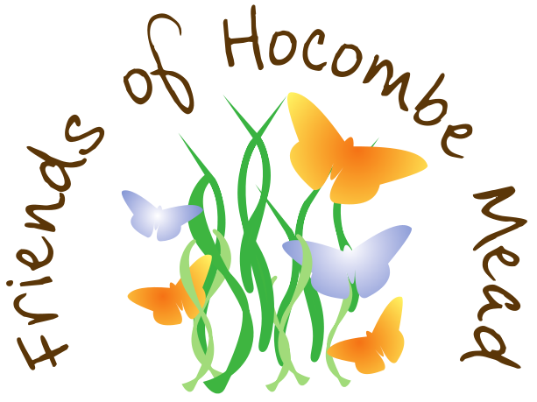

Hocombe Mead Biscuits

225g/8oz plain flour
150g/5 ½ oz butter
125g/4 ½ oz caster sugar
1 teaspoon vanilla extract
caster sugar for dusting

Pre-heat your oven to 180C/350F/Gas Mark 4.

Lightly grease a baking tray

Sieve the flour into a large mixing bowl and rub in the butter with your fingers (or whiz it up in the food processor).

Add the sugar and vanilla extract and bring the mixture together into a dough.

Roll the dough out and cut out shapes with your cutter. Arrange them on the baking sheet.

Bake in the oven for 15 to 20 minutes (until a light golden colour).

Transfer to a wire rack to cool and dust with a little caster sugar.

Variation

Use boiled sweets to give your butterfly biscuits more colour.

Prepare the biscuit dough and cut out the biscuits as per the recipe but line your baking sheet with baking paper before putting on your biscuits.

Crush the boiled, fruit flavoured sweets in their wrappers.

When your biscuits are on the baking tray, cut out a small circle in each wing and fill them with shards of the sweets.

Bake as per the recipe.

The sweets will melt in the oven to fill the holes.

Allow the biscuits to cool on the baking tray.

